HYDROGEN

BEHAVIOUR OBJECTIVES
At the end of this lesson, students should be able to;
- explain the unique position of hydrogen in the periodic table.
- list 3 isotopes of hydrogen.
- describe the industrial preparation of hydrogen.
- outline 3 physical and chemical properties of hydrogen.
- list 6 uses of hydrogen.
- test for hydrogen in the laboratory.

Hydrogen is the lightest element known, it is found uncombined in the atmosphere. It is widely combined with other elements in the form of water, acid, organic substance (carbohydrate, protein, fats), petroleum products(kerosene, gasoline, natural gas).

UNIQUE POSITION OF HYDROGEN IN THE PERIODIC TABLE
Hydrogen can be positioned to be a group 1 element (alkali metal) because it has one electron in its valence shell, has the tendency to lose one electron to become H⁺ ion, as well as, it combines with non-metals to form oxides, sulphides and it is a good reducing agent BUT unlike group 1 elements, hydrogen is a non-metal, its oxide is neutral and not basic, and also hydrogen exists in gaseous state and not in solid state. So, it cannot be fully place in group 1.
On the other hand, it can be positioned to be a group 17 element (halogen), as hydrogen needs on electron to attain inert gas configuration, it is a non-metal and exist as diatomic, it also can gain one electron to form hydride BUT unlike group 17 elements, hydrogen has less tendency to gain electrons than halogens, its oxide is neutral and not acidic. So, it cannot be fully place in group 17.
Hence, hydrogen is considered to be in a group of its own.

ISOTOPES OF HYDROGEN
Isotopes are atoms of the same element with same atomic number but different mass number.
Hydrogen exist in three isotopic forms, namely;
- Hydrogen or Protium ${}_{1}^{1}H$ 1s¹,
- Deuterium or heavy hydrogen ${}_{\text{1}}^{\text{2}}{\text{D or }{}_{\text{1}}^{\text{2}}{\text{H}}}$,
- Tritium ${}_{\text{1}}^{\text{3}}{\text{Tor }{}_{\text{1}}^{\text{3}}{\text{H}}}$
Deuterium forms an oxide, D₂O, which commonly known as heavy water. Tritium is an unstable isotope and it is radioactive.

ELECTRONIC CONFIGURATION OF HYDROGEN
The first element on the periodic table and the lightest element known, with atomic number = 1 and mass number = 1. (proton number =1, electron number =1, neutron number = 0).
Electronic configuration = 1s¹

HYDROGEN MOLECULE
Hydrogen has only one electron in its orbital. So, during the formation of the hydrogen molecule, the orbitals of two hydrogen atoms containing one unpaired electron with opposite spin overlap with each other along the internuclear axis. This overlap is called Axial overlap, and it results in the formation of a covalent bond.
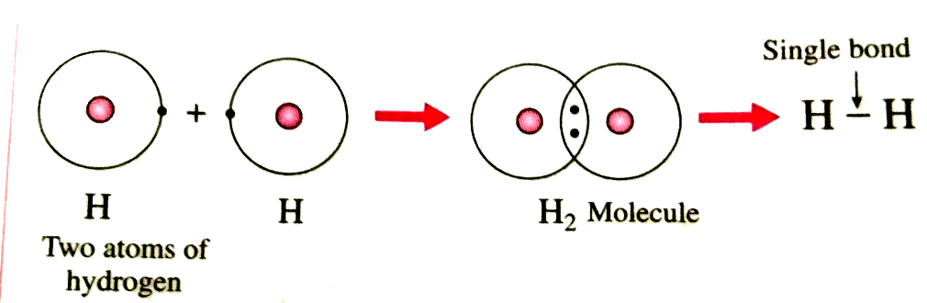 v

LABORATORY PREPARATION OF HYDROGEN
- Action of dilute acid on zinc.
Zn_{(s)} + H₂SO_{4(aq)} → ZnSO_{4(aq)} + H_{2(g)}
- Action of cold water on active metal.
2Na_{(s)} + 2H₂O_{(l)} → NaOH_{(aq)} + H_{2(g)}
- Action of steam on red-hot carbon.
3Fe_{(s)} + 4H₂O ⇄ Fe₃O_{4(s)} + 4H_{2(g)}

INDUSTRIAL PREPARATION OF HYDROGEN
- From water gas (Bosch process)
Steam is passed over the red-hot coke at about 1100ºC, a mixture of carbon (ii) oxide and hydrogen known as water gas is produced.
C_{(s)} + H₂O_{(g)} → CO_{(g)} + H_{2(g)} [Endothermic Reaction]
Excess steam is mixed with the water gas and passed over suitable catalyst (Fe₂O₃ or chromium (iii) oxide) at 450ºC. The carbon(ii) oxide is then converted to carbon(iv) oxide with more hydrogen.
CO_{(g)} + H_{2(g)} + H₂O_{(g)} ⇄ CO₂ + 2H_{2(g)} [Exothermic Reaction]

- By Electrolytic Method
Hydrogen is obtained as by-product of the electrolysis of brine, acidified water (dilute H₂SO₄).

- From Hydrocarbon
Methane is passed with steam over a nickel catalyst at about 800ºC and 30 atm, a mixture of carbon (II) oxide and hydrogen known as synthetic gas is produced.
CH_{4(g)} + H₂O_{(g)} → CO + 3H_{2(g)}
The synthetic gas is the mixed and passed over suitable catalyst (Fe₂O₃ or chromium(III)oxide) at 450ºC. The carbon(II)oxide is then converted to carbon(IV)oxide with more hydrogen.
CO_{(g)} + 3H_{2(g)} + H₂O_{(g)} $\underset{→}{ {\text{Fe}}_{\text{2}}{\text{O}}_{\text{3}} }$ CO₂ + 4H_{2(g)}

PHYSICAL PROPERTIES OF HYDROGEN
- Pure hydrogen is a colourless and odourless gas.
- It is neutral to litmus.
- It is the lightest substance known.
- It has a very low boiling point of about -253ºC.

CHEMICAL PROPERTIES OF HYDROGEN
- Reacts with active metals to form ionic hydrides
2Na_{(s)} + H_{2(g)} → 2NaH_{(s)}
- Reacts with halogens to produce halides
Cl_{2(g)} + H_{2(g)} → 2HCl_{(g)}
- Reacts with oxygen: pure hydrogen burns with pale blue flame as it combines with oxygen to produce steam.
2H_{2(g)} + O_{2(g)} → 2H₂O_{(g)}
- It is a strong reducing agent
CuO_{(s)} + H_{2(g)} → Cu_{(s)} + H₂O_{(g)}

USES OF HYDROGEN
- It is used in filling balloons (due to its low density but it is highly flammable).
- Used in the manufacture of ammonia (Haber process), hydrochloric acid, methanol.
- Used in hardening vegetable and animal oil for the manufacture of margarine, soap, candles.
- Used in the production of water gas and coal gas.

TEST FOR HYDROGEN
Insert a lighted splint into a test-tube containing an unknown gas. If it burns with a pop sound, then the gas is hydrogen. (the pop sound is due to the violent combination of hydrogen with oxygen in air, to produce steam).

DRILL QUESTIONS

- Which of the isotopes of hydrogen is radioactive?
- ${}_{1}^{1}H$
- ${}_{\text{1}}^{\text{2}}{\text{H}}$
- ${}_{\text{1}}^{\text{3}}{\text{H}}$
- ${}_{\text{1}}^{\text{4}}{\text{H}}$

- Which of the isotopes of hydrogen is known as heavy hydrogen?
- ${}_{1}^{1}H$
- ${}_{\text{1}}^{\text{2}}{\text{H}}$
- ${}_{\text{1}}^{\text{3}}{\text{H}}$
- ${}_{\text{1}}^{\text{4}}{\text{H}}$

- Effect of hydrogen on litmus
- Turns red litmus blue
- Turns blue litmus red
- Neutral to litmus

- From the reaction:
Fe₂O_{3(s)} + 3H_{2(g)} → 2Fe_{(s)} + 3H₂O_{(g)}
Hydrogen is behaving as …………….?
- Oxidizing agent
- Reducing agent
- Steam donor
- Hydride

ANSWER
- C
- B
- C
- B

